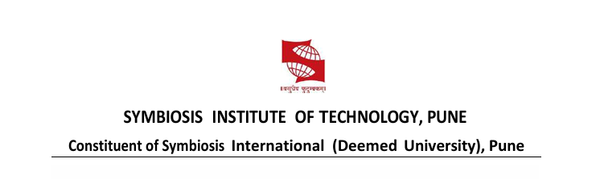
Name of Student: DAKSH JAIN PRN:25070122070
Subject: Programming with JAVA Sem: III AY: 2026-27
Assignment No: 14
TITLE: Write a Java program to demonstrate exception handling using try and catch blocks, nested and multiple try-catch blocks.

Problem Statement
Write a Java program to demonstrate exception handling using try and catch blocks,
nested and multiple try-catch blocks.
Learning Objectives
To handle runtime exceptions using try-catch, nested try, and multiple catch blocks.
Theory
Exception handling prevents abnormal termination of programs due to runtime errors. The
try block contains code that may generate exceptions, while catch blocks handle specific
exceptions. Nested and multiple try-catch structures allow complex error management.
Exception handling improves software reliability and user experience by gracefully
managing unexpected situations.
Exercise
1. Create an ATM program handling invalid withdrawal amount using try-catch
import java.util.Scanner;

public class ATM {
public static void main(String[] args) {

Scanner sc = new Scanner(System.in);

int balance = 10000;

try {
System.out.print("Enter withdrawal amount: ");
int amount = sc.nextInt();

if (amount <= 0) {
throw new Exception("Withdrawal amount must be greater than zero.");
}

if (amount > balance) {
throw new Exception("Insufficient balance.");
}

balance = balance - amount;

System.out.println("Withdrawal Successful!");
System.out.println("Remaining Balance: " + balance);

} catch (Exception e) {
System.out.println("Error: " + e.getMessage());
}

sc.close();
}
}

OUTPUT:
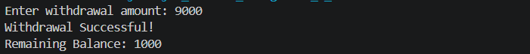

2. Create an Online Shopping program that handles an invalid product quantity entered by
the user using a try-catch block. Display an appropriate error message if the quantity is less
than or equal to zero.
import java.util.Scanner;

public class OnlineShopping {
public static void main(String[] args) {

Scanner sc = new Scanner(System.in);

try {
System.out.print("Enter product quantity: ");
int quantity = sc.nextInt();

if (quantity <= 0) {
throw new Exception("Invalid quantity! Quantity must be greater than zero.");
}

System.out.println("Order placed successfully.");
System.out.println("Quantity Ordered: " + quantity);

} catch (Exception e) {
System.out.println("Error: " + e.getMessage());
}

sc.close();
}
}
OUTPUT:

